Assignment

Documentation

- Ritesh

Dated (14.11.2022)

**Assignment: Technical Description**

In this Documentation, we will discuss and represent how to deploy a serverless containerized application at Amazon ECS Fargate with AWS Copilot.

Moreover, we have to look at AWS Copilot deployment and AWS CI/CD pipeline-based deployment workflow for serverless containerized applications.

**AWS Architecture**

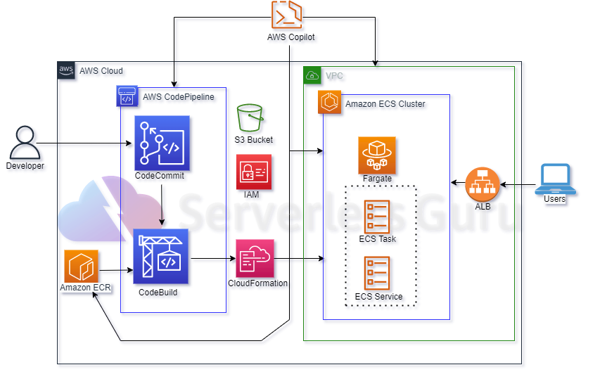

In this AWS Architecture Diagram shows how AWS Copilot CLI is used to deploy Serverless Containerized Applications on Amazon ECS Fargate both the way normal and CI/CD pipeline workflow-based deployment.

**AWS Copilot** 🡪

The AWS Copilot CLI is a tool for developers to build, release, and operate production-ready containerized applications on Amazon ECS, AWS Fargate, and AWS App Runner. From getting started, pushing to staging, and releasing to production, Copilot can help manage the entire lifecycle of your application development.

**AWS ECS** 🡪

Amazon ECS is a fully managed container orchestration service that makes it easy for you to deploy, manage, and scale containerized applications.

**Setup Environment**

In this environment, we have to install multiple services to run the process.

* AWS CLI (Command Line Interface), AWS Configure
* AWS Copilot CLI
* Build and Run Docker Images
* Docker Build
* Docker Run

Deploy to Amazon ECS Fargate with AWS Copilot, Where we using Copilot Init command, this will help to initialize and deploy.

**Mobaxterm:-**

MobaXterm is a remote desktop solution that provides businesses with networking tools such as VNC, RDP, or FTP and various Unix commands to manage jobs on remote Windows desktops.

--It’s a tool that is used to run such commands

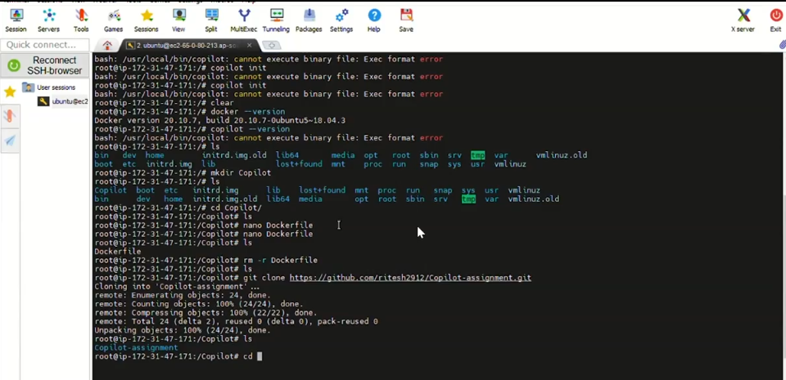

#### ****Docker Image Pushed to Amazon ECR****

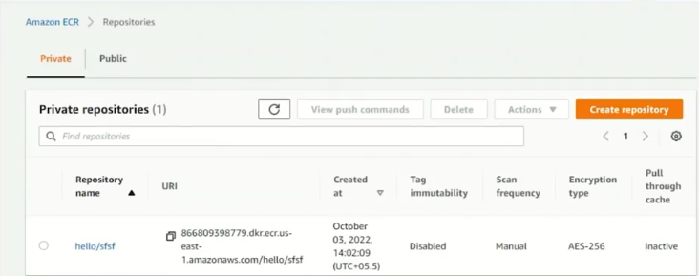

#### ****Amazon ECS Cluster Details Which Auto Created****

#### 

#### ****AWS CodePipeline Source Step****

#### 

#### Pipeline source step auto using that same AWS CodeCommit repository which we created and added as remote for project in which initialize copilot pipeline.

#### ****AWS CodePipeline Build Step****

#### 

#### Copilot pipeline deploy auto created new Build Project and used same as part of this CI/CD Pipeline.

#### ****AWS CodePipeline Deploy Step****

#### 